

**Inflation and the Global Economy**

Speech given by

Timothy Besley, Member of the Monetary Policy Committee, Bank of England

At the Canada-UK Chamber of Commerce, London 22 April 2008

I am grateful to Neil Meads and Paolo Surico for their help and insights in preparing this speech, and colleagues for comments. The views expressed are my own and do not necessarily reflect those of the Bank of England or other members of the Monetary Policy Committee.

1

All speeches are available online at [www.bankofengland.co.uk/publications/Pages/speeches/default.aspx](http://www.bankofengland.co.uk/publications/Pages/speeches/default.aspx)

Ladies and Gentlemen, thank you for coming.

Had I been speaking here a year ago on the challenges faced by the Monetary Policy Committee (MPC), I would have emphasised the inflationary implications of the robust expansion in the UK economy in the face of mounting capacity pressures and some signs of a pick up in global inflationary pressure. You will recall that April 2007 was the month in which, for the first time, the Governor of the Bank of England was obliged, under the accountability arrangements put in place by the 1997 framework, to write an open letter to the then Chancellor of the Exchequer, Gordon Brown, explaining why inflation had risen to 3.1% in March, more than one percentage point away from the target of 2%. That letter underlined the determination of the MPC to take whatever action would be necessary to return inflation to target. It also explained why the MPC expected that inflation would fall back towards target as increases in domestic energy prices, in particular, dropped out of the base of the Consumer Price Index (CPI). This expectation was realized with inflation dipping a little below the target at 1.9% in July of last year.

While the first open letter after a decade of the post-independence period attracted a good deal of attention, it is important to look at the period since writing the letter in a wider context. Looking back, there is little to suggest that this period of above target inflation led to second-round effects in wages and prices that could constitute the beginning of an inflationary spiral away from the target. Nonetheless, measures of inflation expectations, especially from surveys and pricing intentions in surveys of businesses have remained elevated since that time.

The main headline event since that period is, of course, the financial market disruption that began last August and remains with us today. The far-reaching implications of this are still being studied. Managing its consequences presents a significant challenge to policy-makers around the world as its effects filter through to businesses outside the financial sector and to households, not least in the latter’s access to mortgage finance. This has created a rather different context for monetary policy compared to a year ago when the inflationary pressures that led to the open letter were accompanied by a robust picture for economic activity.

However, in common with a year ago, the challenge of responding to inflationary pressures remains. Prior to the publication of the February 2008 *Inflation Report*, I was struck how the focus on the financial market turmoil had largely deflected attention away from concerns about inflation. The MPC’s remit is to maintain price stability by targeting 2% CPI inflation and,

subject to that, to support the Government’s economic objectives for growth and employment. Given this, we are obliged to remain firmly focused on the implications of developments in the economy for inflation in the medium term. There is now widespread recognition of the fact that the challenge for the MPC in setting interest rates is to try to balance two significant risks to the UK economy – the downside risk to demand and output which could eventually drag inflation below the target and the risk that upside shocks to energy and food prices lead to a more persistent period of inflation above the 2% target that becomes embedded in inflation expectations.

One striking feature of the inflationary pressure that we face in the UK is how far this is being mirrored by the experience in other countries. Inflation in the eurozone is 3.6%, the highest since the inception of the euro. In the US it is 4.0%1, in China 8.3% and in India 7.8%2. All are higher than a year ago. The fact that all countries have experienced increases in energy, food and other commodity prices is a significant factor. Wheat prices have risen from US$4.50 per bushel to US$7.62 per bushel and oil from US$65 per barrel to $111 per barrel over the past twelve months3. These, of course, reflect the strong global economic performance in recent times – powered by the spectacular performances by India and China whose average annual growth rates have exceeded 8.5% and 10.2% respectively over the past five years. In short, the world does appear to have become a more inflationary place of late.

Looking at these issues in a broader historical context, the synchronous movement in inflation rates across industrialized economies4 is quite striking. This can be seen in Chart 1, and it has been the subject of a number of recent economic analyses.5 Many of you here will have lived through the early part of the period in this chart – sometimes labelled “the Great Inflation”. The Chart illustrates just how similar inflation rates have been across the industrialized world, with most countries experiencing high and volatile inflation during the 1970s and part of the 1980s, and low and stable inflation thereafter. The cause of this moderation in inflation is much

1 Headline CPI inflation for March 2008.

2 Based on Indian wholesale price index.

3 Number 2 soft red wheat and Crude Oil prices reported for 18 April 2008.

4 Here, I will focus here on the experiences of nine countries only: Australia, Canada, France, Germany, Italy,

New Zealand, Japan, UK and US. However, the arguments discussed here are relevant to most OECD economies.

5 See for instance Rogoff (2003), Ciccarelli and Mojon (2005), Borio and Filardo (2007), and Mumtaz and Surico (2008).

debated.6 In a nutshell, there are three main candidates: good luck, structural economic change and good policy.

The suggestion that the moderation in inflation is down to *good luck* argues that economies have not, in more recent times, been subjected to too many inflationary cost shocks of the kind that we saw, in particular, with the two oil price hikes of 1973 and 1979. This, so the story goes, has diminished the challenges faced by policy-makers charged with controlling inflation.

Given that the current pressure on inflation is so readily attributed to food and energy price pressures, it is tempting to believe that such movements are exceptional and that the great moderation was a reflection of stable commodity prices. In fact, this turns out not be true as is illustrated in Chart 2 which shows little evidence of a reduction in volatility in primary goods prices over either period.7

When I was first taught economics in the 1970s, it was sometimes suggested that the oil price shocks of 1973 and 1979 caused the ‘Great Inflation’. But it was soon realized that this does not work as an explanation of inflation since these shocks were sudden and temporary while the inflation that they created was persistent. Of course, some kinds of commodity prices – notably oil – do generate temporary fluctuations in inflation as they pass through to households. But they cannot account, on their own, for persistent inflation. Indeed, Chart 3 shows that, excluding the episodes of 1973 and 1979, oil price inflation and a measure of international inflation are virtually uncorrelated. 8 So I think that we need to look elsewhere to understand what drives the persistent patterns in inflation seen in Chart 1.

One possibility is to look behind the causes of the current increases in commodity prices – which are largely attributable to the strength of the global economy, particularly the integration into the world economy of China and India.

Perhaps bouts of inflation in the industrialized world are then simply a reflection of global economic success. Chart 4 looks at this issue plotting the relationship between global economic growth and international inflation in a sample of nine OECD countries suggesting a negative

6 The academic literature now uses the term the “Great Moderation” to refer to the decline in the volatility of output growth. Here, I note that a similar decline occurred in the level and volatility of inflation across most industrialized economies.

7 See Walton (2006) for a discussion of why the UK economy may have become less vulnerable to oil shocks.

8 A similar result is reported by Mumtaz and Surico (2008).

relationship between the two. Viewing this relationship as a structural feature of the global economy is tempting, but there are at least a couple of reasons to resist such a temptation.9 First, in a world of floating exchange rates, there is scope for exchange rates to adjust across countries in response to domestic and foreign shocks.10 Second, the recent period of global growth has been associated with an expansion in world trade that has reduced the costs of many manufactured goods in particular.11

The *structural change* explanation for lower rates of inflation in recent years puts weight on the idea that fundamental reforms to product and labour markets, particularly in response to increased competition due to trade openness, has increased the flexibility of economies. This, in turn, makes it less likely that a given shock to costs or to demand results in inflationary pressure.12 While there is little doubt that some economies are more flexible now than in the past, it is not at all obvious that this should result in lower inflation even though there may be many other beneficial consequences of increased flexibility. In particular, another feature of Chart 4 – the observation that the rates of output growth in industrialized economies have been considerably less volatile since the mid-1980s – may well be attributable in part to increased flexibility.

The third explanation for the more recent experience of low inflation emphasises *good policy*. This has also been discussed extensively in the recent academic and policy literature.13 Before turning to this in detail, let me begin with the observation that most, though not all, OECD countries appear to have had somewhat similar policies in the two periods documented in Chart

1. To see this, it is useful to look at Chart 5 which gives the short term interest rate in a sample of OECD countries. The Chart illustrates the proposition that policies (in terms of central bank policy rates) have tended to move together.

However, this observation tells us little on its own since the challenges being faced by policy makers were similar too. To believe that policy played a role in the moderation of inflation, one

9 Borio and Filardo (2007) construct measures of the global output gap and show that these measures have some marginal predictive power for domestic inflation, over and above measures of domestic slack, using data for a panel of OECD countries. Ihrig et al. (2007) assess the robustness of their results and provide evidence against the hypothesis that globalization has increased the relative role of international factors in shaping the inflation process across eleven OECD countries. See Mishkin (2007) for an overview of this debate.

10 See Sentance (2007).

11 See, for example, Pain *et al*., 2007.

12 See Bean (2006) for further discussion.

13 See, for example, Rogoff (2006) and Cecchetti et al. (2007).

would need also to observe that the stance of policy was similar across countries. Chart 6 gives us one clue on this. It plots the *real* interest rate, i.e. the policy rate adjusted for inflation, in nine countries over the period that I have been discussing. The message that I take away from this is that the period of high and volatile inflation was associated with *negative* real interest rates, which can be interpreted as symptomatic of a relaxed monetary policy. The most recent period of low and stable inflation is characterized, in contrast, by *positive* and higher real rates of interest.

This observation is consistent with what sometimes is called the Taylor principle – the notion that, in response to inflationary pressures, a central bank that wishes to maintain control over inflation needs to raise the nominal interest rate enough to generate a positive real rate. The fact that the central bank is expected to conform to the Taylor principle contributes to managing the demand side of the economy and keeps inflation expectations anchored around low inflation.

Furthermore, the experience of recent years suggests that once credibility is established, inflation can be kept under control through sequences of small changes of the policy rate in the same direction.

This view that monetary policy matters argues that the main contrast between the two broad periods of inflation experience in Chart 1 can be attributed to a significant change in central bank responses to inflation. In the 1970s and 80s there were few central banks whose policy responses to inflation provide a sufficient tightening of policy in the face of inflation to anchor public beliefs around low and stable inflation. As is made clear by Chart 6, an exception to the general picture was the Bundesbank which kept stable and positive real interest rates over this period with the result that German inflation remained low and stable even though it was subject to the same international cost shocks as the other countries in this Chart.14

In the United States, monetary policy changed notably in the 1980s during Paul Volcker’s tenure as chairman of the Fed. He began the process of disinflation in the United States economy which initiated a fundamental change in the intellectual climate on monetary policy thinking, leading ultimately to the adoption of explicit inflation targeting mandates in New Zealand in 1990, Canada in 1991, the UK in 1992, Sweden in 1995 and other countries thereafter (see Chart 7).

But the constituency for low inflation was not built in a day. It took some time for the low inflation norm, supported by appropriate monetary policy, to become enshrined in behaviour.

14 This argument comes from Mumtaz and Surico (2008).

During the period of low and stable inflation, monetary policy in the UK has been focused on the control of inflation, in line with the remit to maintain price stability. But, having been so successful in achieving this end, there is a danger that monetary policy will be asked to do more. In particular, monetary policy makers may be expected to protect the economy against persistent real shocks in the mistaken view that adjustments in real living standards can be avoided. This is an important issue in the UK at the present time when the economy is going through a period of rebalancing away from consumption and towards closing our current account deficit. At the same time, we are adjusting to the real implications of the credit shock. Monetary policy can perhaps smooth some of the adjustment in response to changes in the real economy. However, in my view, it cannot (and should not, therefore, try to) prevent warranted real economy changes taking place.

Given the immediacy of the present, it is always tempting to think that the lessons of history offer little help to the challenges that we face today. But I think that there are two main lessons worth thinking about in the current context.

First, this brief tour of history serves as a reminder that inflation targeting was born of a practical recognition that monetary policy *can* be used to manage inflation. The experience of the past suggests that using monetary policy to support the economy in the face of negative real productivity shocks had little success. In many cases, central banks were made independent and given their inflation targeting remits to avoid a repeat of these errors. This affects the strategy of the MPC in a subtle, but important, way. In line with our remit, monetary policy in the UK ought to remain focused on achieving price stability as defined by the inflation target. Hence, we should avoid trying to offset downside shocks to the real economy except in so far as they lead to downside risks to inflation in the medium term. The remit does, however, give the MPC the scope to exercise its judgement about the best way to influence the path of the economy towards that objective.

Among the reasons that I welcome the initiative announced by the Bank of England yesterday is that it is targeted directly at alleviating a key stress that has followed from the current disruption in financial markets. This should allow the MPC to stay more focused on its task of using monetary policy to target inflation.

Second, there are challenges faced by the pressures that come from the similarities and differences in the policy stances of central banks around the world. One of my earliest academic papers was on the role of yardstick competition in shaping public policy decisions.15 The focus of that work was on the observation that tax reforms (particularly increases in taxation) appeared to be correlated across states in the United States. It turned out that Governors of US states did not like to put up taxes unilaterally and there was an electoral cost to them of doing so. But if they put up taxes when Governors in surrounding states were also putting up taxes, then the electoral effect appeared muted. The main lesson from this strand of research is that particular domestic policies can be accepted more easily by the public if they are adopted also by countries that share a similar macroeconomic performance. The experience of the ‘Great Inflation’ of the 1970s as well as of the current credit crunch makes me only too aware of real time yardstick competition when strategies are being compared around the world. But, in the face of this, it is important to remain focused on implementing the policy that is needed based on circumstances here in the UK

The MPC is now beginning its series of meetings leading up to the publication of the May *Inflation Report*. These meetings provide a good opportunity for us to look in greater detail at some aspects of the challenges that we currently face. In particular, it will be possible to process all the economic news since February and to assess how it affects the balance of risks, both upside and downside, to achieving the inflation target in the medium term. The arrangements that we now have in the UK allow the MPC to do so reflectively and independently, drawing on the considerable technical expertise of the Bank of England’s staff. Our inflation targeting remit anchors the discussions of the MPC so that we, in turn, can do our best to keep businesses’ and households’ inflation expectations anchored around the 2% target. This provides the best context to maintain the credibility of the framework that we have in the UK and allows monetary policy to play its part in maintaining the stability that is needed for households and businesses to plan for the long-term.

**References**

**Bean, C (2006)**, 'Comments on Ken Rogoff: "Impact of globalization on monetary policy"', Jackson Hole conference on 28th August, at [www.bankofengland.co.uk/publications/speeches/2006/speech281.pdf.](http://www.bankofengland.co.uk/publications/speeches/2006/speech281.pdf)

**Besley, T and Case, A (1995)**, ‘Incumbent Behaviour: Vote Seeking, Tax Setting and Yardstick Competition’, *American Economic Review*, 85, 1, March 1995: 25-45.

15 See Besley and Case (1995).

**Borio, C and Filardo, A (2007)**, ‘Globalisation and inflation: New cross-country evidence on the global determinants of domestic inflation’, *Bank for International Settlements Working Paper no. 227*.

**Cecchetti, S, Hooper P, Kasman B, Schoenholtz K and Watson, M (2007)**, ‘Understanding the Evolving Inflation Process’, *US Monetary Policy Forum 2007*.

**Ciccarelli, M and Mojon, B (2005)**, ‘Global inflation’, *European Central Bank Working Paper no. 537*.

**Ihrig, J, Kamin, S, Lindner, D and Marquez, J (2007)**, ‘Some simple tests of the globalisation and inflation hypothesis’, Board of Governors of the Federal Reserve System, *International Finance Discussion Paper no. 893*.

**Mishkin, F (2007)**, ‘Globalization, Macroeconomic Performance, and Monetary Policy’, *Speech delivered on September 27th at the Domestic Prices in an Integrated World Economy Conference, Board of Governors of the Federal Reserve System, Washington, D.C.*

**Mumtaz, H and Surico, P (2008)**, ‘Evolving international inflation dynamics: evidence from a time-varying dynamic factor model’, *Bank of England Working*

*Paper no. 341* and *CEPR discussion paper no*. *6767*.

**Pain, N, Koske I and Sollie, M (2007)**, ‘Globalisation and inflation in the OECD economies’,

*OECD Working Paper no. 524*.

**Rogoff, K (2003)**, ‘Globalisation and global disinflation’, paper prepared for Federal Reserve Bank of Kansas City conference, Jackson Hole.

**Rogoff, K (2006)** ‘Impact of Globalization on Monetary Policy’, paper prepared for Federal Reserve Bank of Kansas City conference, Jackson Hole.

**Sentance, A (2007)** ‘The Global Economy and UK Inflation’, speech at an event organised by the Leeds Financial Services Initiative on 24 September, at [www.bankofengland.co.uk/publications/speeches/2007/speech322.pdf.](http://www.bankofengland.co.uk/publications/speeches/2007/speech322.pdf)

**Walton, D (2006)** ‘Has Oil Lost the Capacity to Shock?‘, speech at the University of Warwick Graduates' Association Senior Directors' Forum on 23 February, <http://www.bankofengland.co.uk/publications/speeches/2006/speech268.pdf>

Chart 1: Inflation in nine industrialized countries

% change oya

**30**

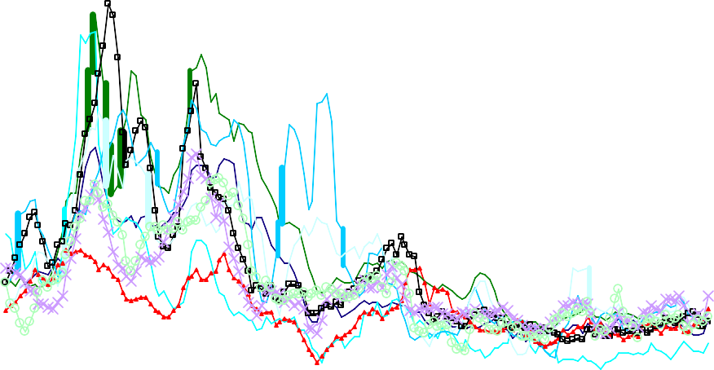

**25**

**20**

**15**

**10**

**5**

**0**

**Q1 1970**

**Q1 1974**

**Q1 1978**

**Q1 1982**

**Q1 1986**

**Q1 1990**

**Q1 1994**

**Q1 1998**

**Q1 2002**

**Q1 -5**

**2006**

France Germany Italy

Japan UK US

Canada New Zealand Australia

Chart 2: International inflation and world commodity prices

% change oya % change oya

20 **100**



18

**80**

16

14 **60**

12 **40**

10

8 **20**

6 **0**

4

**-20**

2

0

**Q1 Q1 Q1**

**Q1 Q1**

**Q1 Q1**

**Q1 Q1**

**-40**

**Q1**

**1970**

**1974**

**1978**

**1982**

**1986**

**1990**

**1994**

**1998**

**2002**

**2006**

CRB Index Goldman Sachs Index

Economist Index Weighted Average Inflation Rate (LHS)

Notes: average inflation base d on the nine countries in Chart 1; weights based on real GDP shares in USD.

Chart 3: International Inflation vs. UK Brent Crude (excluding 1973 and 1979)

% change oya

150



100

50

**UK Brent Crude.**

0

-50

-100

0 4 8 12 16

**Weighted Average Inflation Rate (%change oya)**

Notes: average inflation base d on the nine countries in Chart 1; weights based on real GDP shares in USD.

Chart 4: International Inflation and the International Business Cycle

% change oya

**18.0 10**



**Weighted Average Inflation Rate (LHS)**

**Weighted Average GDP Growth (RHS)**

**15.0**

**8**

**12.0**

**6**

**9.0**

**6.0 4**

**3.0**

**2**

**0.0**

**0**

**-3.0**

**-6.0 -2**

**1970 1973 1976 1979 1982 1985 1988 1991 1994 1997 2000 2003 2006**

Notes: averages base d on the nine countries in Chart 1; weights based on real GDP shares in USD.

Chart 5: Co-movements in Short-term Interest Rates (demeaned)

**20**

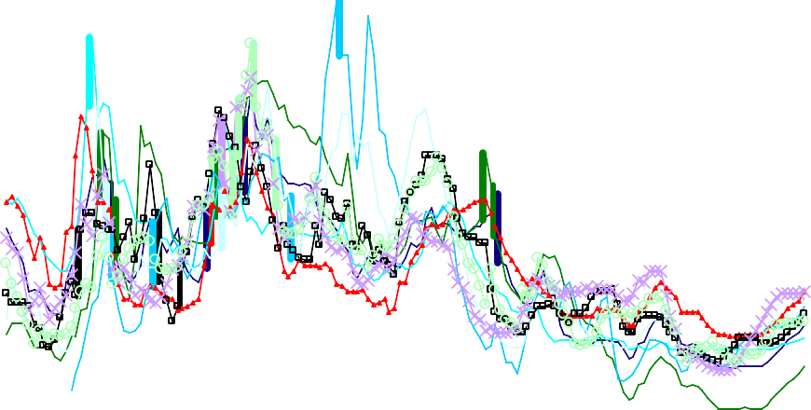

**10**

**0**

**-10**

|  |  |  |  |  |  |  |  |  |  |
| --- | --- | --- | --- | --- | --- | --- | --- | --- | --- |
| **Q1** | **Q1** | **Q1** | **Q1** | **Q1** | **Q1** | **Q1** | **Q1** | **Q1** | **Q1** |
| **1970** | **1974** | **1978** | **1982** | **1986** | **1990** | **1994** | **1998** | **2002** | **2006** |

France Germany Italy

Japan UK US

Canada New Zealand Australia

Chart 6: Inflation and Real Interest Rates

25

20

15

10

5

0

−5

−10

−15

AUSTRALIA

25

20

15

10

5

0

−5

−10

−15

CANADA

25

20

15

10

5

0

−5

−10

−15

FRANCE

1970 1975 1980 1985 1990 1995 2000 2005

1970 1975 1980 1985 1990 1995 2000 2005

1970 1975 1980 1985 1990 1995 2000 2005

25

20

15

10

5

0

−5

−10

−15

GERMANY

25

20

15

10

5

0

−5

−10

−15

ITALY

25

20

15

10

5

0

−5

−10

−15

JAPAN

1970 1975 1980 1985 1990 1995 2000 2005

1970 1975 1980 1985 1990 1995 2000 2005

1970 1975 1980 1985 1990 1995 2000 2005

25

20

15

10

5

0

−5

−10

−15

NEW ZEALAND

25

20

15

10

5

0

−5

−10

−15

UNITED KINGDOM

25

inflation

real rate

20

15

10

5

0

−5

−10

−15

UNITED STATES

1970 1975 1980 1985 1990 1995 2000 2005

1970 1975 1980 1985 1990 1995 2000 2005

1970 1975 1980 1985 1990 1995 2000 2005

Chart 7: Inflation and Monetary Policy Regimes

(a)

(b) (b') (c) (d)

% change oya

**28**

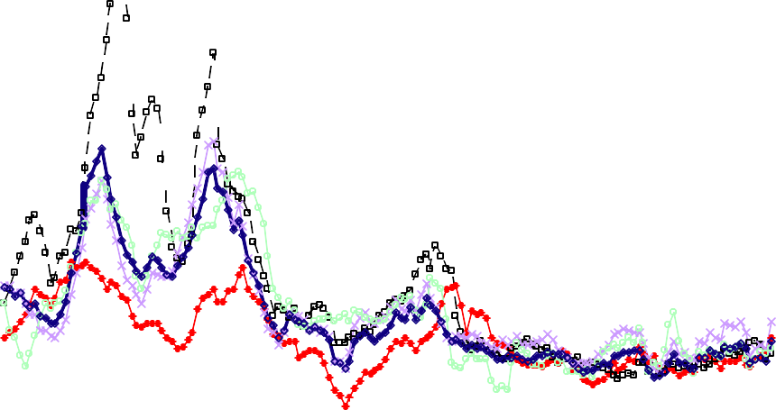

**24**

**20**

**16**

**12**

**8**

**4**

**0**

Germany UK

US Canada

'Weighted Average Inflation Rates'

* 1. Collapse of Bretton Woods (1973)

**Q1 -4**

**2006**

|  |  |  |  |  |  |  |  |
| --- | --- | --- | --- | --- | --- | --- | --- |
| **Q1** | **Q1** | **Q1** | **Q1** | **Q1** | **Q1** | **Q1** | **Q1 Q1** |
| **1970** | **1974** | **1978** | **1982** | **1986** | **1990** | **1994** | **1998 2002** |

* 1. Volcker appointment as Fed Chairman (1979); (b’) Volcker’s disinflation (1982)
  2. Inflation targeting adopted by Canada (1991)
  3. Inflation targeting adopted by UK (1992)